Quick Facts

Surface--- 7,682,300 km²

Capital City--- Canberra (328 000)

Biggest city--- Sydney

Population--- 18 500 000

People--- 94% European descent, 4% Asian, 1.5%

Government--- Union state, member of the Commonwealth

Language--- English, Australia language

Religion--- Protestant

Average temperature--- 14 degrees Celsius

National day--- January the 26th

Longest river--- Murray Darling 3370km

Highest recorded temperature in Australia--- 53 degrees Celsius

Coldest recorded temperature in Australia--- Minus 23 degrees Celsius
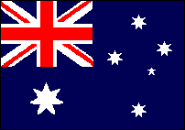

History / The Aboriginals

Australia was discovered by an Englishman named James Cook, he was born in Yorkshire the 27th of October 1728.
He boarded Australia 1770. When Cook came to Australia there already lived people there, The Aboriginals.
Today the Aboriginals have it really hard, many of them are unemployed and they have a hard time to support themselves.
James Cook died the 14th of February 1779 on Hawaii probably by cannibals.

After James Cook boarded Australia many “white men” came to this marvellous island. And the aborigines were more and more separated and mistreated.

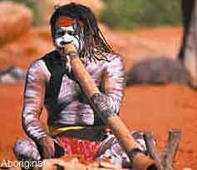

Koala

The Koala is a animal and look like a teddybear. It’s about 80 cm tall and can weight up to 15 kilos. The Koala multiplies very slowly and gives birth to a kid-koala every second year.
The koala’s coat is very thick which is very strange for a warm climate like in Australia. The Koala is a night animal who sleeps very much at the day and search for food at night.
It sleeps about 19 hours and searches for food the rest of the time. A Koala always sleeps and lives alone that to mark their territory.

Kangaroo

Some Kangaroos live alone, some live in families with a bond that lasts a lifetime, while some travel in large mobs.
A Kangaroo can sprint 40 mph over a 1-2 mile distance and 20 mph for long distances such as 10 miles or more.

Generally, they live for 20 years in captivity and approximately six years in the wild. The most common colours of Kangaroos are grey and red, but they can also be black, yellow or brown. Occasionally there are albino or white kangaroos.

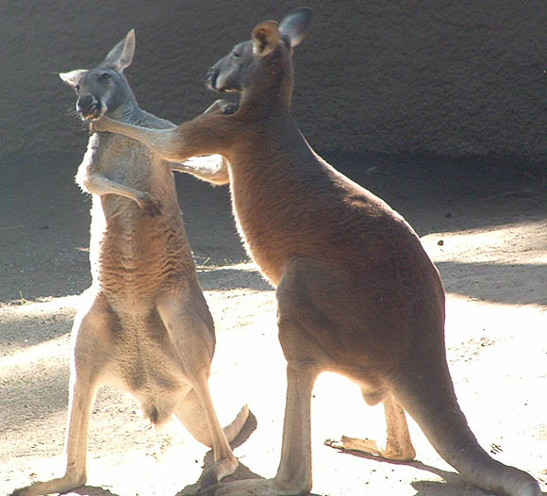

The thing that makes Australia so popular is of course the beaches, the warm climate, the nature and their undersea nature. They have a thing called “The Great Barrier Reef” it´s more than 2000 km of living undersea creatures. The islands surrounding the reef are home for more than 16000 living species.

The Great Barrier Reef

The Great Barrier Reef is a diverse and delicate ecosystem situated along the coast of Queensland in Australia. The reef is over 2000 kilometers long and is considered to be the largest living structure on the earth. The Great Barrier Reef is even clearly visible from the moon. Above some of the reefs there are islands in different sizes for example “Whitsunday”. 400 different types of corals, fish and other species like sea snakes, sea turtles, populate the reef and even whales come to visit during the winter.

The world's first coral reefs occurred about 500 million years ago, and the first close relatives of modern corals developed in southern Europe about 230 million years ago. By comparison, the Great Barrier Reef is relatively young at just 500,000 years old. The current reef's structure is much younger at less than around 8,000 years old.

A coral reef is a natural barrier made of the bodies of living and dead coral. It is the corals who give the reef its colorful appearance. Coral grows in warm climates where there is salt water and sunlight, and they do not like pollution.
The coral reef is made of two parts. The white part is made from the bodies of many polyps that have died long ago. The colorful part is the living part of the reef. It is made up of living polyps.
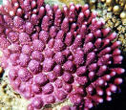
Coral reefs are found in shallow water, ranging to depths of 60 m. Some species prefer either cooler temperate water while others are found along tropical reefs, such as the Great Barrier Reef, with waters ranging in temperatures from 18 - 33 °C.

Threats to the Great Barrier Reef

* Human beings are often a threat to the coral reef. The rivers of Australia end by the coast where the coral reef is situated. From the rivers lots of sediments and pollution is pulled out into the ocean and this affects the reef.

* We humans also destroy the reef mostly by the millions of tourists who visit the reef. Snorkellers, divers and reef walkers often break or abrade corals through contact, some people even take corals with them even though it is not aloud.

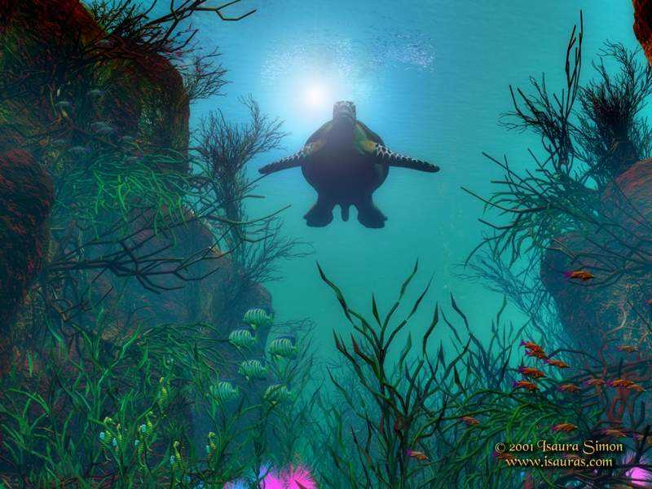

Towns

Sydney is the biggest town in Australia. About 3.5 million people live there.
The Olympic games were in Sydney year 2000 and that opened the eyes for many tourists.
If you think that Sydney is the capital city you have wrong.
The capital city is a small town named Canberra.
In Canberra is it only about 300 000 inhabitants.
Melbourne is a harbortown in the south of Australia. Its about 3.2 million inhabitants there and it is the second largest town in Australia.
Other big towns in Australia are Perth wich is on the westcoast,
Darwin in the north, Brisbane on the eastcoast and Adelaide.

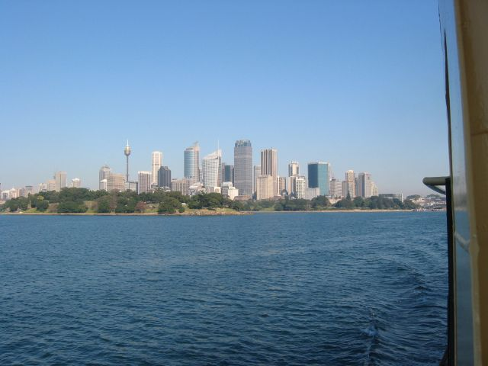

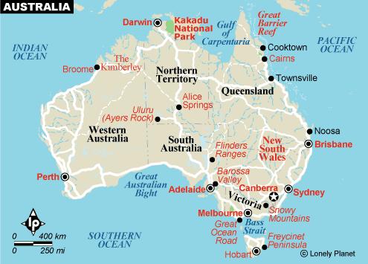

Sights

Operahouse
The Operahouse in Sydney is a world-known building.
It was very difficult to build, it took almost 14 years and it was finished in 1973.
The architect was the Danish man Jörn Utzon.
Actually is it not one house, its three. One concerthouse, one Operahouse and one restaurant.
It is over one million pieces of tiles on the roof and the tile is from Sweden.
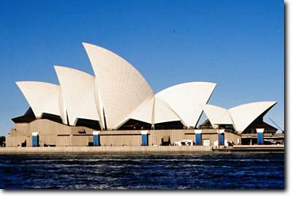

Ayers rock / Uluru

Ayers Rock/ Uluru, the world's largest monolith and an Aboriginal sacred site is Australia's most famous natural landmark. Visitors may wish to make the tough 1.6km ascent to the top or take a walking tour around the rock with an aboriginal guide , learning about its fascinating with the Uluru people and its importance in dreamtime legend.
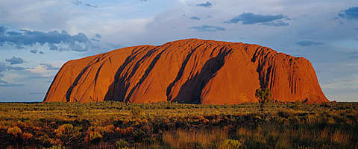

Byron bay

Byron bay is on the westcoast. It is surfers paradise and very nice beaches. If you are a tourist and want to have nice water, warm weather and nice beaches you have to go to Byron bay!
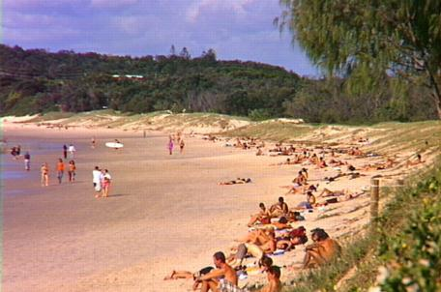

Climate

The tropical states Queensland and the Northern Territory have highly predictable weather. In “winter'', typical daily maximums are from 20 to 24 degrees Celsius and rain is rare. The beaches and tropical islands of Queensland and the Great Barrier Reef are perhaps at their most pleasant at this time of year.
Further south, is not the weather that hot, in Melbourne in August maximums as low as 13 degrees Celsius are possible, but can reach as high as 23 degrees Celsius.
In summer, the northern states are hotter and wetter, while the southern states are simply hotter, with temperatures up to 41 degrees Celsius in Sydney, Adelaide, and Melbourne but generally between 25 and 33 - very pleasant indeed.
It is not usual with snow. Only one time in 10 years. But it is high peaks there it is snow more usual.
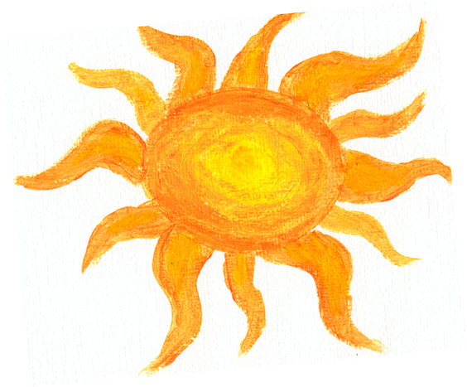

Nature
In Australia is it very varying nature. From undestroyed beaches to high mountains.
The biggest part of Australia is dry, desserts and steppes.
On the eastside is it nice beaches and the Great Barrier reef.
In the north is it some tropical rainforests.

Industries

Forest industry
Australia’s forest and wood products industries have an annual gross turnover of more than 15.1 billion dollar per year.
Over 86 000 people are directly employed in Australia's forest industries, including 65 000 directly employed in the manufacture and processing of wood and paper products, and over 13 000 in growing and processing.

Uran industry
10 percent of the worlds uran is coming from Australia.

Sugar industry
Australia is currently one of the world's largest exporters of raw sugar, with Queensland exporting about 80 to 85 percent of its total raw sugar production. Almost 100 percent of raw sugar exports originate in Queensland. Total sales of Queensland raw sugar are around $2 billion annually.
In 1997 season Australia produced 5.74 million tonnes (Mt) of raw sugar.
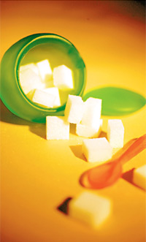

Sources

http://www.barrierreefaustralia.com/the-great-barrier-reef/coralfacts.htm

http://www.wwf.org.au/About_WWF_Australia/How_we_work/Campaigns/Great_Barrier_Reef/facts.php

http://www.australia.com/home_uk.aust?country=GB&JSESSIONID=Bk33vnvj%211027910877%211105475447265&enter=enterEnhanced&L=en&C=GB

http://www.worldtourism.com.au/Victoria/Melbourne/facts&figures.htm

http://www.sydneycity.net/sydneyfacts.htm

http://www.asienguiden.com

http://www.mimersbrunn.com

http://www.utsikt.nu/guider/start.asp

http://www.susning.nu

Av: Andreas 2004

